APM 3183 - Update Sonar Provisioning and Config Management Scripts – SonarQube Validation Steps

# Verifying Sonar

* Use the URL to access the SonarQube dashboard http:// <IP of the instance where Sonar is installed>>:9000 /sonars
* Login using default username and password.

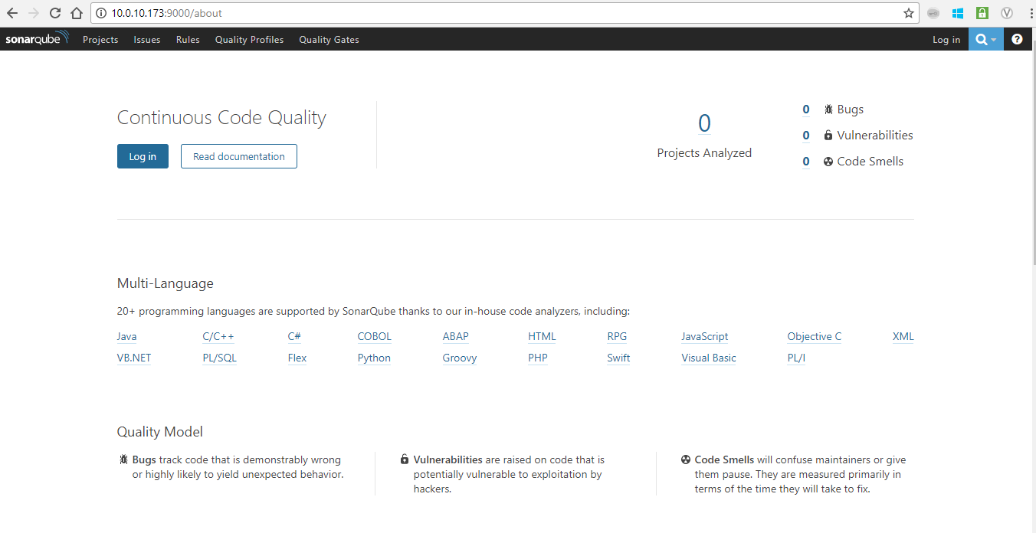

# Verifying External DB Connectivity

* Once the Sonar Dashboard is loaded, If the connectivity is successful, DB gets populated with the tables.

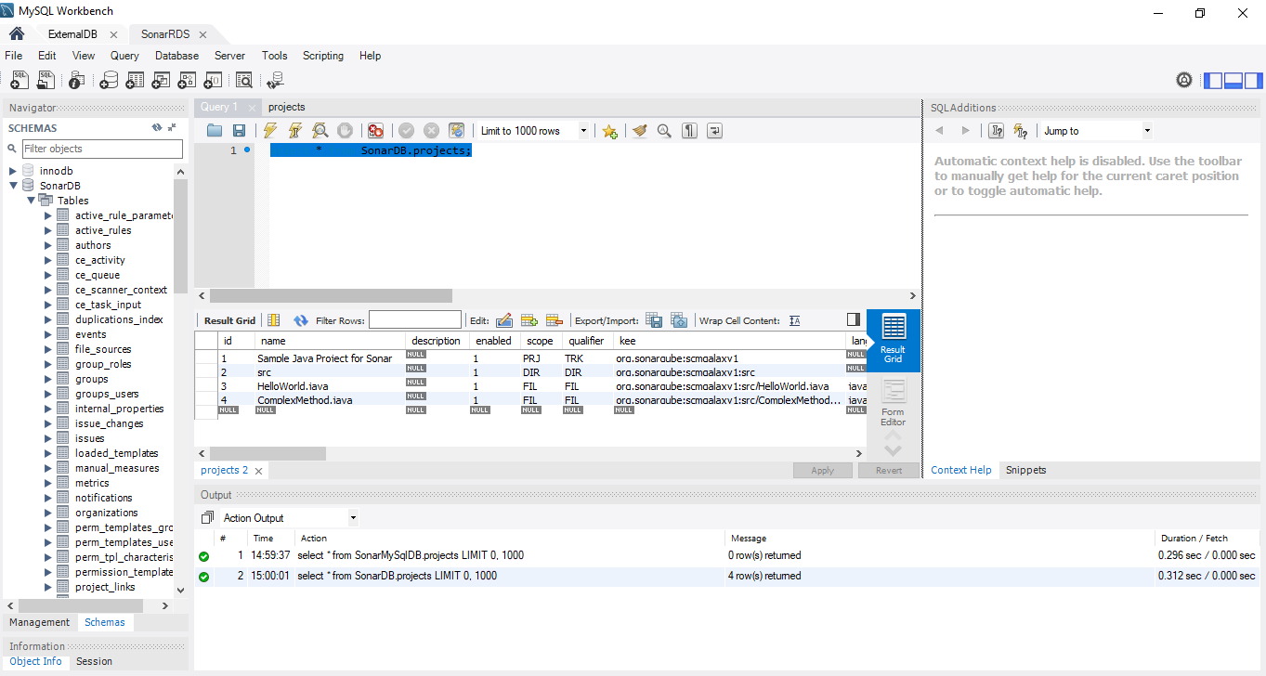

# Validate Sonar using sample project

## [Installing and Configuring SonarQube Runner](https://docs.sonarqube.org/display/SONARQUBE52/Installing+and+Configuring+SonarQube+Scanner) Locally

* First, we need to install SonarQube locally. SonarQube Runner is recommended as the default launcher to [analyze a project with SonarQube](https://docs.sonarqube.org/display/SONARQUBE52/Analyzing+Source+Code).
* Download Link - <http://repo1.maven.org/maven2/org/codehaus/sonar/runner/sonar-runner-dist/2.4/sonar-runner-dist-2.4.zip>

## Installation

* Expand the downloaded file into the directory of your choice. We'll refer to it as *<install_directory>* in the next steps.
* Update the global settings (server URL) by editing *<install_directory>/conf/sonar-runner.properties*:

|  |
| --- |
| #----- Default SonarQube server  #sonar.host.url=<http://localhost:9000> |

* Create a new *SONAR_RUNNER_HOME* environment variable set to *<install_directory>*.
* Add the *<install_directory>/bin* directory to your path.
* You can check the basic installation by opening a new shell and executing the command sonar-runner -h / on Windows platform the command is sonar-runner.bat -h. You should get a message like this:

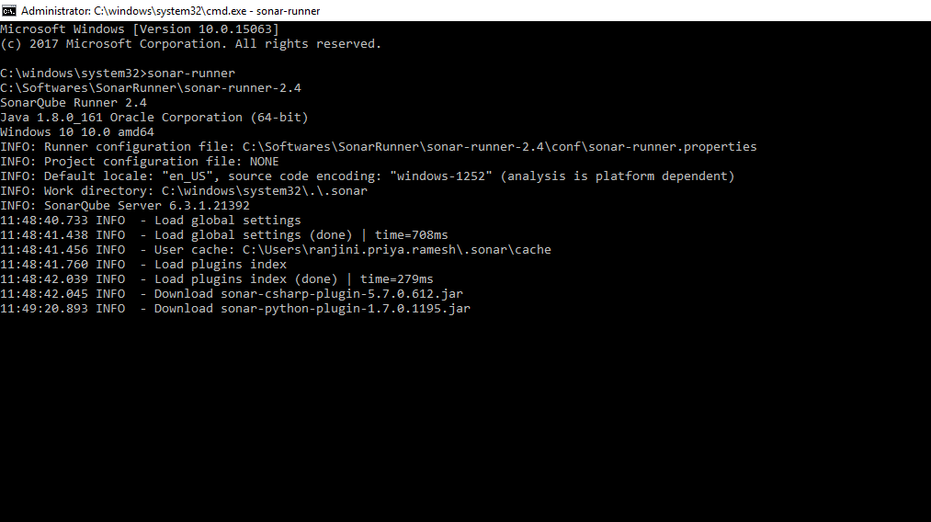

## 

## Code coverage Report in Sonar Dashboard

* Start the SonarQube server
* Create **sonar-project.properties** file in the project root path with the following configuration

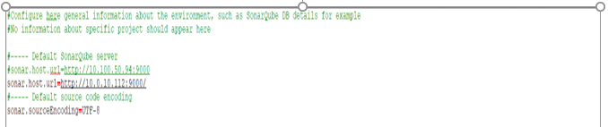

* Execute the sonar-runner command from the project root path
* Once the execution is successful, we can see the coverage report in SonarQube dashboard.

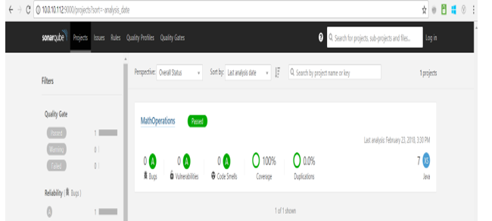

# Verifying External Database